i-Finance UAT Results — Task Management (App 207)
Automated UAT run · Round 4 · 20-Jun-2026 · Environment: http://localhost:8094 (dev-proxy → ADB PROD)
Executed by Claude (Playwright + ORDS). Round 4 focus: the Reporting-Cycle wave — reporting cadences + member check-ins, the cross-DCT executive view (scorecard + achievement badges), cross-team visibility grants (executive exceptions) and the row-level security retrofit, admin custom-role CRUD, parent-child team hierarchy, the AI period summary, and the Gantt/timeline view. Personas: SYS_ADMIN (ADMIN) and a non-admin member (SHAIKHA.GALAMERI). Test data created during the run is prefixed "UAT".

Summary
28 cases — PASS: 28
Area | Cases | Pass | Fail/Other | Pass %
Reporting Cycle | 10 | 10 | 0 | 100%
Executive View | 4 | 4 | 0 | 100%
Visibility & Security | 5 | 5 | 0 | 100%
Custom Roles | 3 | 3 | 0 | 100%
Team Hierarchy | 2 | 2 | 0 | 100%
AI Summary | 2 | 2 | 0 | 100%
Timeline | 1 | 1 | 0 | 100%
Access | 1 | 1 | 0 | 100%

Reporting Cycle

TM-CYC-01 — Save a reporting cadence
PASS · Cadence config · 3s
Expected: Cadence saved and rendered on the Reporting Cycle page
Result: Monthly cadence saved (ALL_MEMBERS, lead 3d, reminders 3,1) and rendered on the Reporting Cycle page
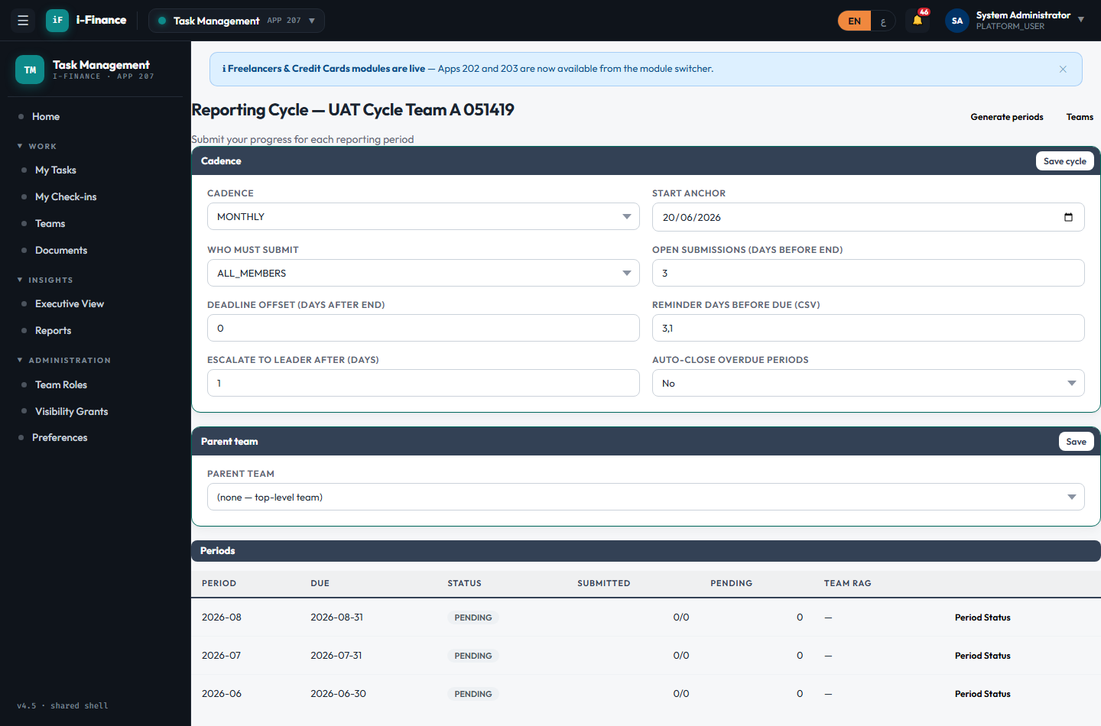
Evidence: TM-CYC-01.png

TM-CYC-02 — Generate + idempotency
PASS · Generate periods · 3s
Expected: Periods generated through the horizon; a second generate adds 0 (idempotent)
Result: Periods generated through the horizon (3) and listed; a second generate is idempotent (0 new)

Evidence: TM-CYC-02.png

TM-CYC-03 — Member saves a draft
PASS · Member check-in (draft) · 8s
Expected: Draft saved and listed in My Check-ins with auto-pulled metrics
Result: Member SHAIKHA.GALAMERI saves a draft check-in; it appears in My Check-ins (2 row)
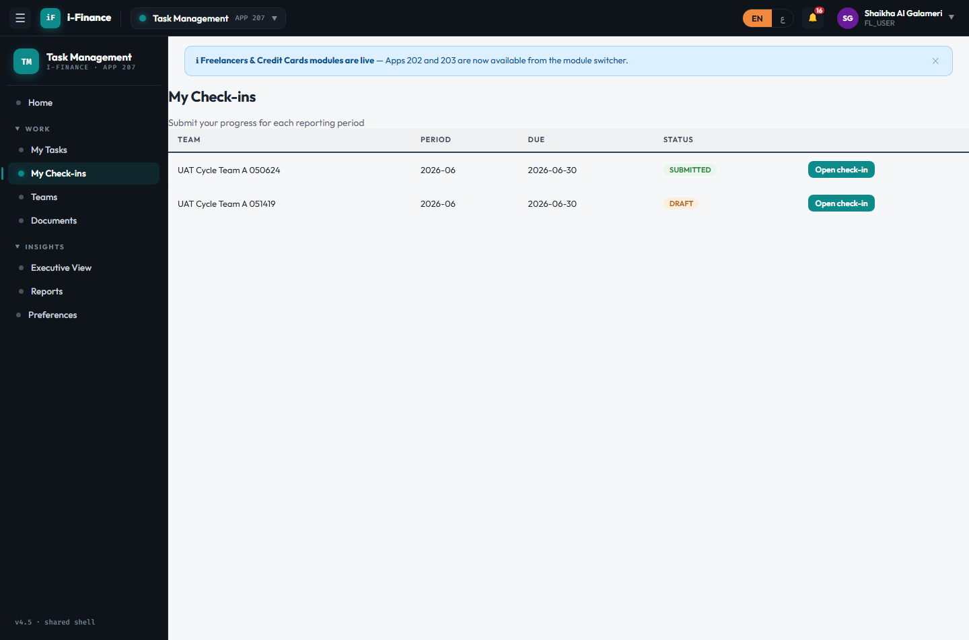
Evidence: TM-CYC-03.png

TM-CYC-04 — Narrative + auto-metrics
PASS · Check-in modal · 4s
Expected: Modal shows narrative fields + read-only auto-metric tiles (tasks done/late/overdue, KPI)
Result: Check-in modal opens with narrative fields + 5 read-only auto-metric tiles
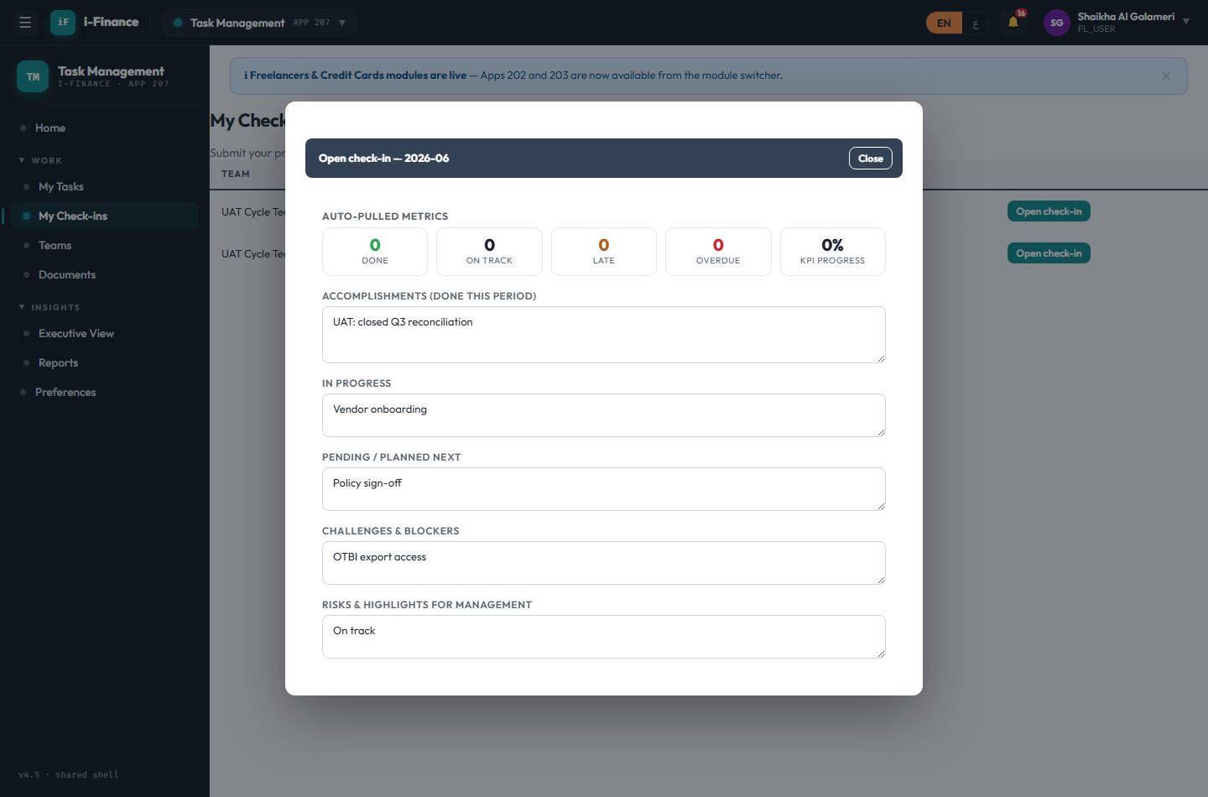
Evidence: TM-CYC-04.png

TM-CYC-05 — On-time submission
PASS · Member submit · 2s
Expected: Status becomes SUBMITTED (or LATE past due) — evaluated server-side
Result: Member submits the check-in → status SUBMITTED (on-time vs. due-date evaluated server-side)
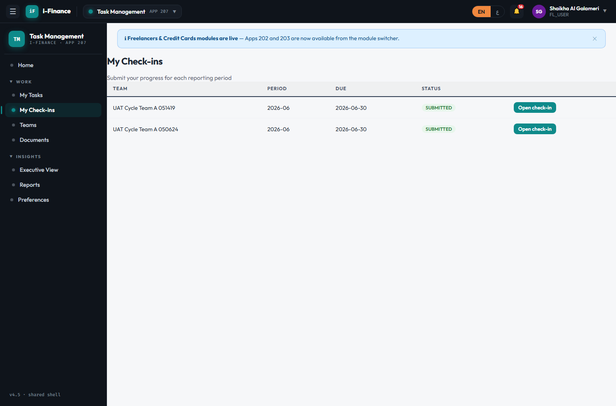
Evidence: TM-CYC-05.png

TM-CYC-06 — Period status roster
PASS · Leader roster · 4s
Expected: Roster lists each submitter with status + metrics; the member shows SUBMITTED
Result: Leader roster (period-status) lists 1 submitter(s); SHAIKHA.GALAMERI shown as SUBMITTED
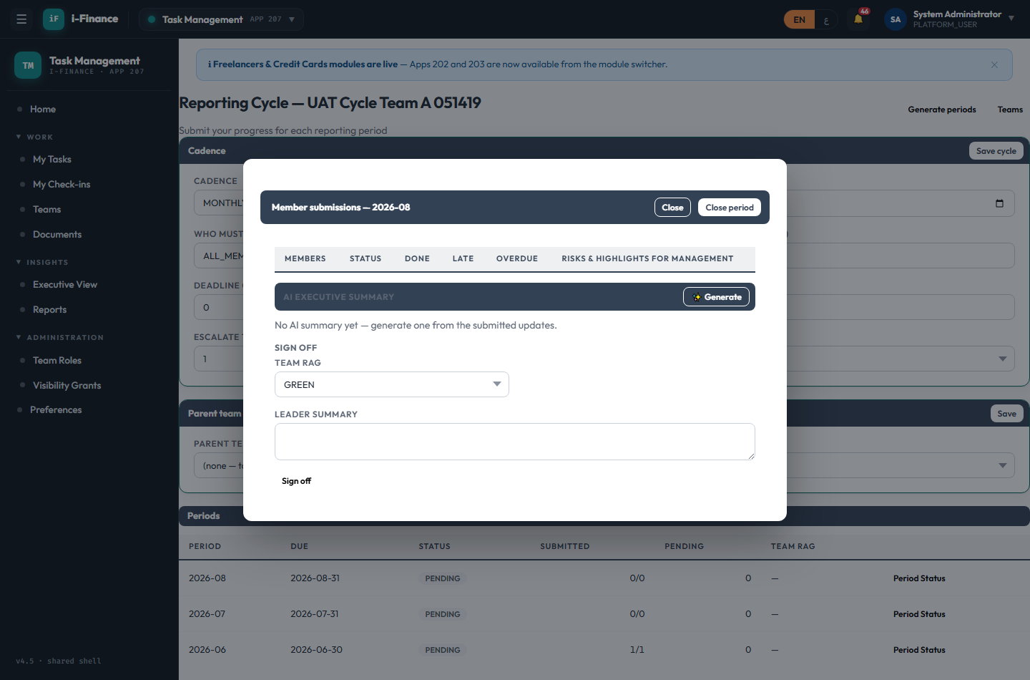
Evidence: TM-CYC-06.png

TM-CYC-07 — Sign off with RAG
PASS · Leader sign-off · 0s
Expected: Sign-off (RAG + summary) stored on the period
Result: Leader signs off the period (RAG GREEN + summary); stored on the period

Evidence: TM-CYC-07.png

TM-CYC-08 — Immutable snapshot
PASS · Close + snapshot · 0s
Expected: Close writes a well-formed, immutable JSON snapshot; status → CLOSED
Result: Close writes an immutable JSON snapshot (1 submission row(s) + sign-off block); period status → CLOSED

Evidence: TM-CYC-08.png

TM-CYC-09 — Edit a closed period
PASS · Closed is read-only · 0s
Expected: Rejected with HTTP 400 (period closed; immutability)
Result: Editing a submission in a CLOSED period is rejected with HTTP 400 (immutability)

Evidence: TM-CYC-09.png

TM-CYC-10 — Freeze the record
PASS · Lock period · 0s
Expected: Status → LOCKED (record frozen)
Result: Period locked (status → LOCKED); historical record frozen

Evidence: TM-CYC-10.png

Executive View

TM-EXE-01 — Roll-up KPIs + charts + scorecard
PASS · Render · 4s
Expected: 4 roll-up KPIs, RAG + on-time charts, and the team scorecard render
Result: Executive view: 4 roll-up KPIs, 2 charts (RAG + on-time), scorecard with 2 row(s)
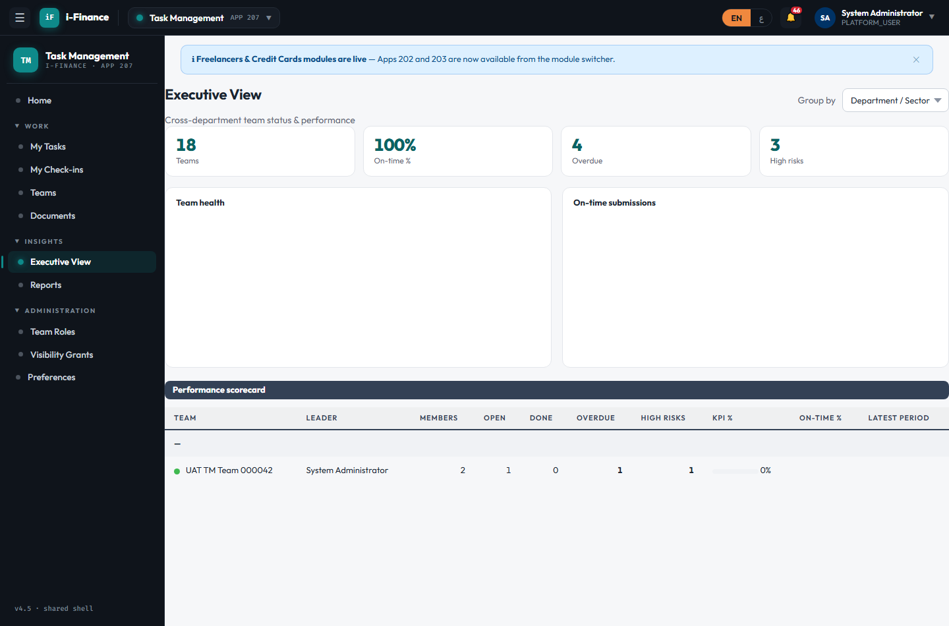
Evidence: TM-EXE-01.png

TM-EXE-02 — Org / team-tree / flat
PASS · Group by · 6s
Expected: The scorecard regroups by org node, by team hierarchy, and flat
Result: Group-by toggle works (org / team-tree / flat); team-tree shows 1 group header(s)
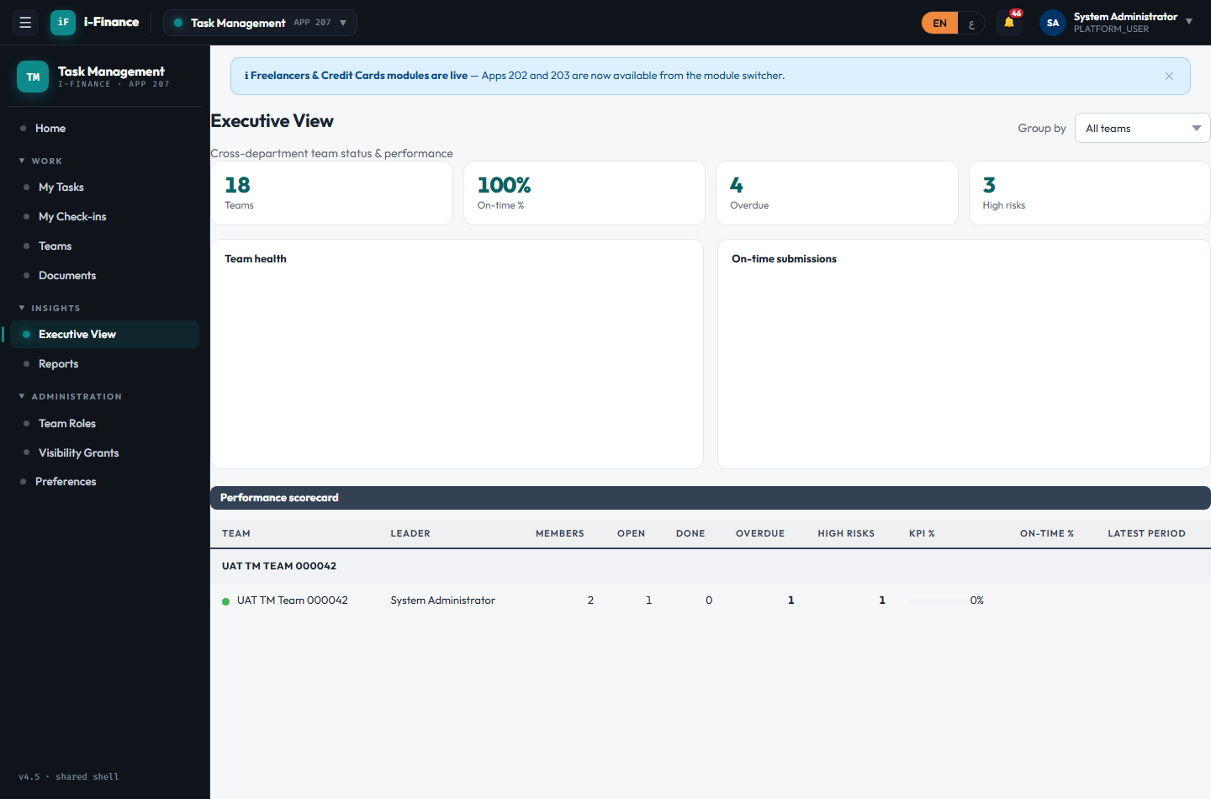
Evidence: TM-EXE-02.png

TM-EXE-03 — Full performance metrics
PASS · Scorecard API · 0s
Expected: Each visible team returns tasks done/overdue, risks, objective %, and on-time rate
Result: exec/teams returns the full scorecard (tasks done/overdue, risks, objective %%) per visible team; team A on-time rate=100%

Evidence: TM-EXE-03.png

TM-EXE-04 — Achievement badges
PASS · Badges · 0s
Expected: Teams qualify for zero-overdue / perfect on-time / all-on-track badges
Result: 14 team(s) qualify for an achievement badge (zero-overdue / perfect on-time / all-on-track)

Evidence: TM-EXE-04.png

Visibility & Security

TM-SEC-01 — Other teams hidden
PASS · Member scope (list) · 0s
Expected: A team the member does not belong to is NOT in their list (row-level scope)
Result: Row-level scope: secret team B is NOT in SHAIKHA.GALAMERI’s team list (sees 2 own/visible team(s))

Evidence: TM-SEC-01.png

TM-SEC-02 — Other team detail denied
PASS · Member scope (detail) · 0s
Expected: Denied with HTTP 403/404 (visibility guard)
Result: Member opening secret team B detail is denied with HTTP 404 (visibility guard)

Evidence: TM-SEC-02.png

TM-SEC-03 — Executive exception
PASS · Grant create · 3s
Expected: Grant created ACTIVE and listed
Result: Admin grants SHAIKHA.GALAMERI VIEWER access to team B (executive exception); listed ACTIVE
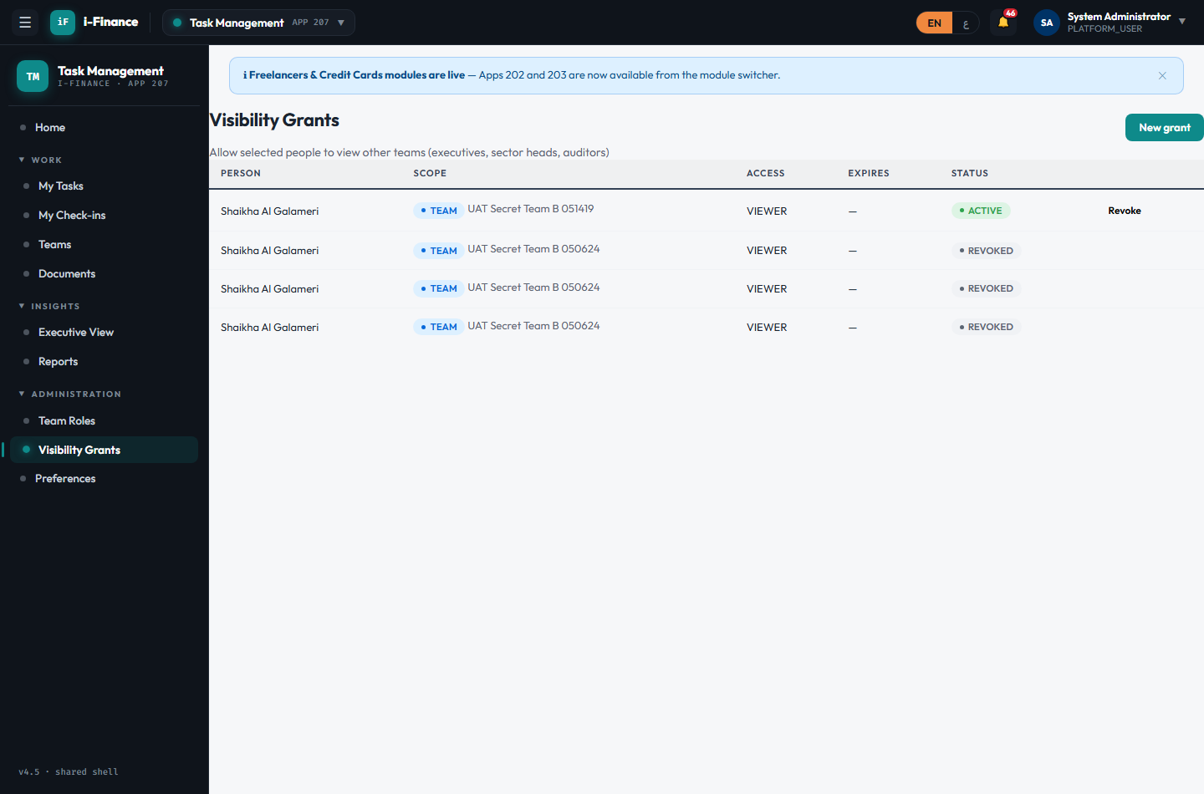
Evidence: TM-SEC-03.png

TM-SEC-04 — Exception takes effect
PASS · Grant exposes · 0s
Expected: The member can now read the team (detail 200 + appears in their list)
Result: With the active grant, SHAIKHA.GALAMERI can now read team B (detail 200 + appears in their team list)

Evidence: TM-SEC-04.png

TM-SEC-05 — Exception removed
PASS · Grant revoke · 2s
Expected: The team is immediately re-hidden (HTTP 403/404)
Result: Revoking the grant immediately re-hides team B from SHAIKHA.GALAMERI (detail → HTTP 404)
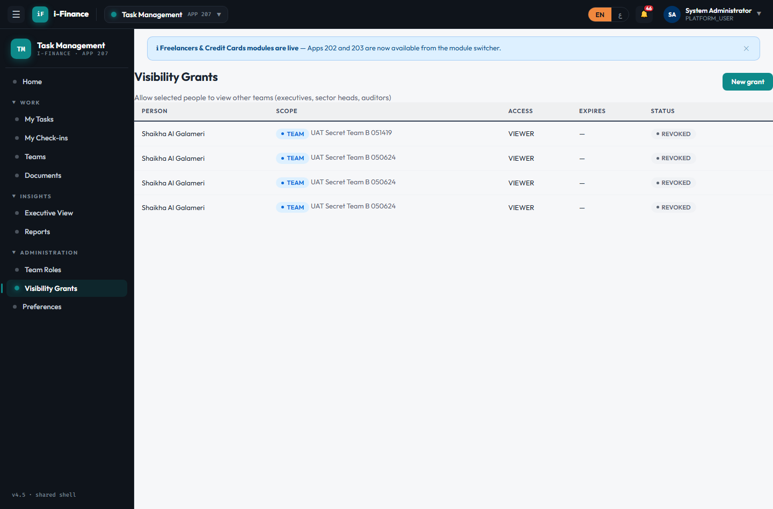
Evidence: TM-SEC-05.png

Custom Roles

TM-ROL-01 — Admin custom role
PASS · Create role · 3s
Expected: Custom team-role created and present in the role list
Result: Custom team-role "UATROLE1419" created (admin) and present in the role list (tmRoleId=42)
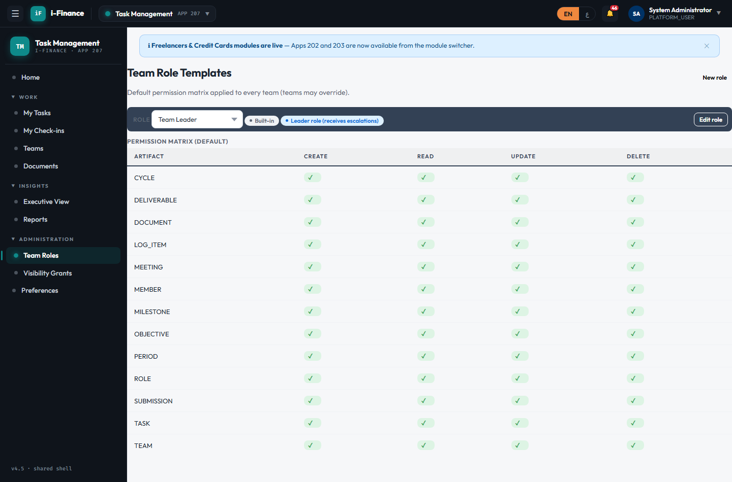
Evidence: TM-ROL-01.png

TM-ROL-02 — Template CRUD matrix
PASS · Edit matrix · 2s
Expected: Template permission defaults updated (e.g. TASK = C/R/U, no Delete)
Result: Template CRUD matrix edited for "UATROLE1419" (TASK = C/R/U, no Delete) via the clickable cells

Evidence: TM-ROL-02.png

TM-ROL-03 — Retire a custom role
PASS · Retire role · 0s
Expected: Custom role retired; built-in (is_system) roles stay protected
Result: Custom role retired (admin); built-in roles remain protected (is_system not deletable)

Evidence: TM-ROL-03.png

Team Hierarchy

TM-HIER-01 — Parent-child link
PASS · Set parent · 0s
Expected: The child team shows the new parent in the team-tree
Result: Team A re-parented under team B; team-tree rolls A up under B (root=44, depth=2)

Evidence: TM-HIER-01.png

TM-HIER-02 — Reject a parent cycle
PASS · Cycle guard · 0s
Expected: Rejected with HTTP 400 (cycle guard)
Result: Creating a parent cycle (B under A while A is under B) is rejected with HTTP 400 (guard)

Evidence: TM-HIER-02.png

AI Summary

TM-AI-01 — AI period summary
PASS · Generate · 5s
Expected: A board-ready narrative is generated from the period data and stored
Result: AI generated a board-ready summary (751 chars) and stored it on the period: "For the June 2026 reporting period, UAT Cycle Team A 051419 achieved full submission disci..."

Evidence: TM-AI-01.png

TM-AI-02 — Non-viewer denied
PASS · Permission · 0s
Expected: Denied with HTTP 403/404
Result: A non-viewer (NASER.ALKHAJA) reading another team’s AI summary is denied with HTTP 403

Evidence: TM-AI-02.png

Timeline

TM-TL-01 — Timeline view
PASS · Gantt render · 3s
Expected: A month axis + bars for tasks/deliverables/milestones render
Result: Timeline/Gantt renders a month axis (2 cells) + 2 bar row(s) for tasks/deliverables/milestones
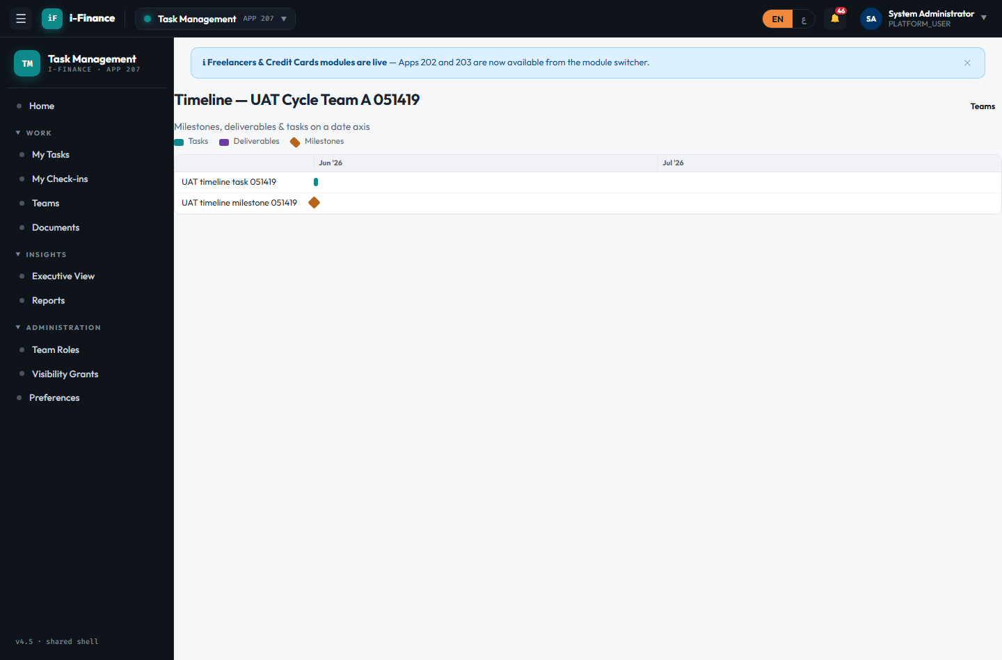
Evidence: TM-TL-01.png

Access

TM-ACC-01 — Role-appropriate nav
PASS · Member nav · 2s
Expected: My Check-ins is available; admin-only Visibility/Roles nav is hidden
Result: Non-admin sees the My Check-ins nav (yes); admin-only Visibility/Roles nav hidden
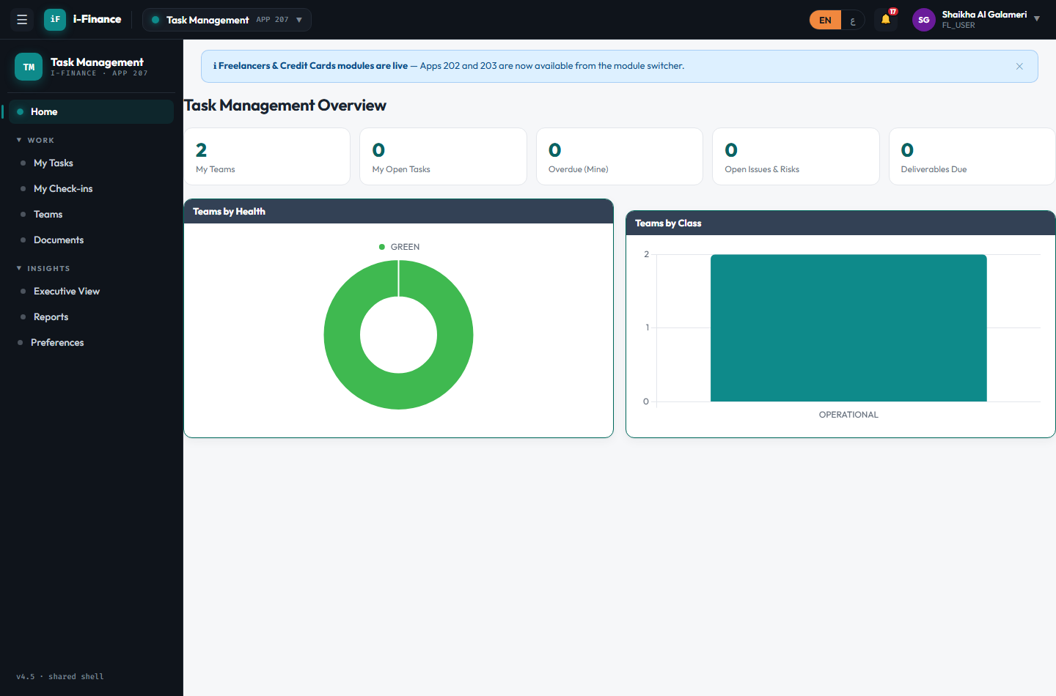
Evidence: TM-ACC-01.png

